Amilcar Torres
Spanish 3070
Dr. Valladares-Ruiz
12/01/2020
Final Project Analytical Paper
The resurgence of narco-organizations and its impacts in present day Mexico
Mexico, a country of 500 million inhabitants, with thousands upon thousands of acres of dense wildlife and ecological wonders has had a long-standing history of drug violence and influence dating back to the mid 20th century. However, throughout time the Mexican government along with cooperation of other western powers such as its neighbor, the United States was able to severely decrease and the cut the power of many of the cartels that ruled the country such as the Sinaloa cartel. This being said, Mexico in the last few years has seen an exponential rise of the influence and power of newly formed cartels, causing huge societal problems. The rise in power and influence of these new narco-organizations has caused a variety of problems within many different regions in Mexico. While there is a plethora of reasons that can be attributed to this new rise in power of these criminal organizations, a new wave of desensitization and indoctrination of the younger generations of Mexico’s citizens has allowed these crime groups to grow exponentially within the last few years. By examining two of the movies we discussed in this course as well as looking at several academic sources and governmental documents, this paper will go about analyzing the new impact that the media has had and how the security and economic issues being cause by these groups could not only effect Mexico but other countries around it such as the United States.
One of the movies which we watched in class this semester was the movie “Maria Full of Grace” a 2004 film directed by Joshua Marston. The main plot follows a character by the name of Maria who is a young woman living with her family in Colombia. The movie helps depict the struggles of people who are living in deep poverty in many parts of Colombia and the type of unsafe and dangerous work and things they have to do to be even able to get bye. Colombia has had a major problem fighting drug cartels and violent criminal groups who transport guns and weapons inside Colombia and to other countries illegally. This has created a system where criminals are able to do as they please with having little to fear for the consequences or repercussions. In the movie, the old man who supplies Maria with the drugs and passport to get to the US is extremely nice and caring of her up until the final moment where he threatens to hurt her family if anything happens to any of the drugs she is carrying. Once she gets to the US she is almost caught and detained for bringing in drugs alongside another woman from the plane, had it not been for the fact that she was pregnant she would have instantly gone to jail upon arrival in the US. After going through a lot of pain and a huge ordeal to be able to drop off the drugs, Maria decides that it will be best for her and her child to stay in the US and not have to go through the ordeal of trying to get back from Colombia. Overall the movie does a very good job displaying the problems and ordeals that these women have to go through and helps show the cycle of violence that a lot of lower-class people in Latin America have to deal with. However, this movie is just a glimpse into the true predatory cycle that is enveloping thousands of young people all across Latin America. Violent criminals will purposefully seek out those who are desperate and in very bad situations to be able to give them an opportunity to make a little bit a money. For these people who are in such bad circumstances, they are willing to take the high risk and commit very illegal acts to be able to make that money and hopefully be able to achieve a better financial situation.
Another film that was discussed in the class was the movie “Narco Cultura” a 2013 film directed by Shaul Schwarz which focused on showing the double perspective to the issue of cartel violence and gang culture. The movie focuses on the “movimiento alterado” which is a new trend popular in Latin America which glorifies and looks up to the lifestyle of drug dealers and drug cartel groups. This trend has been popular through the use of “narco corridas” which are short songs in Spanish which deal with a wide variety of subjects that have to do with drug cartel groups and violence. In the movie multiple songs are seen and heard which talk about the violence and killing that comes from cartel groups as well as the glorification of the use of dangerous drugs. This new shift in culture and trend has led to younger generations to look up to these singers and famous artists from these areas who praise all the violence and glorification of drugs. This subsequently causes the young generations to look up to the cartels and drug leaders themselves as they are often talked about and represented in these songs and videos. This comes at the expense of all the people who have been genuinely negatively affected by cartel violence or drugs. In the movie, several families and people are depicted which shows them talking about their missing family or relatives who were killed directly because of cartel violence. A lot of common citizens in these Latin American countries who have no involvement at all with these criminal groups are the ones who suffer the most from their negative influence. It is common for random civilians to be casualties of conflict between cartel groups and lose family members despite having no involvement. In the movies, it is seen that the leaders of these “narco corrida” groups purposefully user vulgar lyrics and explicit details of cartel violence to popularize their songs and make them appealing to not only the cartel groups themselves, but also a lot of people who have not been personally affected by cartel violence. The movie also helps depict how these cartels are using these songs, and even having songs specifically made for them, to grow their popularity and get more membership. By using this music and videos to indoctrinate the younger generation, they are able to maintain a steady flow of new members joining and thus expanding their total overall influence. This shows a popular trend amongst a wide variety of criminal groups not only in Mexico and Latin America but around the world. By influencing the minds of younger and younger generations, these criminal groups are not only able to grow their following, but also the amount of power and influence that they have as well. In Mexico, it was reported that in 2020 there had been a major increase in the amount of children, those categorized under the age of 18, have been reported to join a variety of these narco-organizations as hit-men or “sicarios” whom they train to use guns and other similar weapons well so that they can carry out any business given to them.
Around the year 2010, a new organization named the Cartel Jalisco New Generation (CJNG) started to rise up and become a rival group to the Sinaloans. However, the CJNG actually started as a “enforcement group” for the Sinaloan Cartel as they were tasked with targeting members of other weaker cartels and executing them to send a message that stated that the Sinaloa Cartel was still in power. The origins of the CJNG can be traced back to the death of Sinaloan Cartel leader Ignacio “el Nancho” Coronel in July of 2010. Shortly after “el Nacho’s” death a power vacuum emerged in Jalisco as several Sinaloan drug cartel members fought for power to establish themselves as the leader of the Jalisco plaza. Jalisco has always been an important location when it comes to the drug business because it is a coastal region so there are many drug routes through the sea, but Jalisco is also a major trafficking point between southern and northern Mexico. Shortly after the death of Coronel, a new leader and his followers took over the remaining infrastructure left behind the Sinaloan Cartel and established the CJNG by targeting the remaining Sinaloan safe houses and eliminating any of its remaining members in Jalisco. Nemesio “El Mencho,” Ramos along with his two of his original top operatives from their time in the Sinaloan Cartel, Erick “el 85” Valencia and Martin “el 53” Ortega took it upon themselves to continue the drug business in Jalisco and subsequently formed the CJNG in early 2011.
Ever since the start of the CJNG they have slowly grown and become one of the biggest and most powerful drug cartels in all of Mexico. Pictured below is a map of the major drug cartels that controlled territory in Mexico as of 2010.
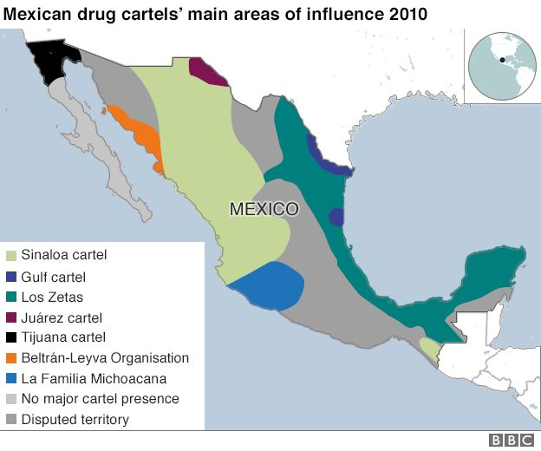
The following map shows the major drug cartels and their territory as of 2017.
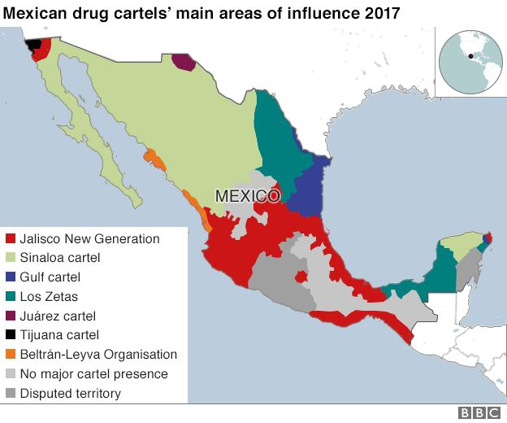
It can clearly be see that the CJNG has slowly been establishing themselves around the southern part of Mexico after expanding from their home state of Jalisco. They were able to expand by slowly taking the territory of Los Zetas, a rival cartel group based along the coast of Mexico. While the map depicts the growing of the Sinaloa cartel, the CJNG have been able to remain a frontrunner cartel by their ability to tap into unconventional markets and increase their profit and influence that way. For decades, cartels in Mexico had the main focus of trafficking drugs solely into the United States. For a long time that was a very successful operation and it made Mexican cartels millions of dollars, however as time passed, it has become increasingly harder to get drugs into the United States because of increases in security and surveillance. In 2012, roughly traffickers 365,000 traffickers were apprehended trying to cross the US border with illegal drugs, however due to higher security and increased funding that number sharply rose to 500,000 just two years later in 2014. This just shows the significant increase in border security as of recent years. However, realizing that it was only becoming harder to get drugs through the US border, the CJNG decided to shift their focus to other areas around the world. By tapping into the European and Asia Pacific region, the CJNG were not only to able greatly increase their influence worldwide, something that many other cartels failed to do, but also, they were able to greatly increase the amount of profit which they make putting them way ahead of other cartels allowing for their rapid expansion. This allowed them to soar ahead of other cartels and be able to take the territory of many cartels in their region. By reaching into different markets the CJNG were also able to keep a relatively low profile and not attract too much attention to their operations in their early years. However, the CJNG quickly became known to be an extremely violent cartel with little regard for civilian life. Mexico has a history riddle with violence and specifically political violence as many political hopefuls have been assassinated throughout time for speaking out against government practices. The best example of this can be seen in the murder of Luis Colosio, a frontrunner for the presidential candidacy in the year 1994 who was shot dead at a political rally after delivering a speech criticizing the practices of the PRI and the corruption than ran rampant in the government.
As the CJNG has grown in power and size, they have been able to acquire more territory, and this has consequently led to more violence. The CJNG are responsible for a 2015 attack on an official government helicopter which killed 8 military soldiers. This helicopter was attacked with a high-grade RPG and was effective in destroying the entire vehicle after just one attack. This was very unprecedented as it was unknown exactly the type of weapon capabilities that the CJNG had at the time and exactly what resources they were using. It is reported that roughly 70% of all fully automatic firearms are transported legally from the United States. And into Mexico. This allows very easy access for the cartels, who have a high amount of liquid cash, to be able to buy large amounts of firearms and effectively make them untraceable so that they could be use in all cartel operations.
This allows the CJNG to be very violent as they have a steady supply of weaponry. And this allows them to exert their influence in regions all throughout Mexico. In the recent years, Mexico has seen a sharp rise in homicide rates with 2018 being the deadliest year in recorded Mexican history. Pictured below is a graphic that helps show the growth of the homicide rate
throughout time. It can clearly be seen that homicides have been rising this 2007 and then dipped back down from 2010-2014. Cartels still remain the highest attributor to homicide in all of Mexico with the CJNG being the frontrunner.
The resurgence of large narco-organizations is something that has had a large-scale effect not only on the lives of those living in Mexico, but also on the media and film. In the article “Cinematic Representations of the Mexican Narco War” by Robert. Bunker, he explains how in the minds of thousands of people all across Latin America, joining these narco=organizations is seen as a form of escape into a more financially stable life that many of poor citizens are able to have. Film and media in Mexico and many other countries has portrayed the process of joining these criminal groups as something that is necessary and “must be done” for a lot of different people as they believe it will be their only option to escape poverty .Cartels have long been a problem in Latin America, especially Mexico. Their influence has seeped within the government and causes decades of corruption and bribery to run rampant. If not properly dealt with now, the CJNG have the potential of becoming the biggest and most powerful drug cartel in Mexican history. The Mexican government needs to take the proper steps now and reach out to its international allies such as the United States to be able to deal with all the problems caused by the CJNG and other similar narco-organizations before it is too late.

“Mexico Sees Rise in Gangs, Vigilantes Recruiting Children.” AP NEWS, Associated Press, 24 Jan. 2020, apnews.com/article/a69b4886eb51293a2f28cc717d0e5676.
Tucker, Duncan. 2018. “Mexico’s Most-Wanted: A Guide To The Drug Cartels”. BBC News. March 27, 2018. https://www.bbc.com/news/world-latin-america-40480405.
2015. “Sector Profile Report”. United States Border Patrol. January 1, 2015. https://www.cbp.gov/sites/default/files/documents/USBP%20Stats%20FY2015%20sector%20profile.pdf.
(n.d.). Mexico: A Cartel’s Rise And Inevitable Fall. Stratfor. Worldview. Retrieved February 18, 2019, from https://worldview.stratfor.com/article/mexico-cartels-rise-and-inevitable-fall
Woody, Christopher. 2018. “Mexico Says It Caught Gunmen Who Shot down an Army Helicopter — and It May Signal Trouble for the country’s Most Powerful Cartel”. Business Insider. August 2, 2018. https://www.businessinsider.com/mexico-catch-cjng-jalisco-cartel-gunmen-who-shot-down-army-helicopter-2018-8.
Ruhfus, Juliana. 2018. “The Day I Got My AK-47: Guns, Mexican Drug Cartels And US Laws”. Al Jazeera. March 21, 2018. https://www.aljazeera.com/blogs/americas/2018/03/day-ak-47-guns-mexican-drug-cartels-laws-180320134720160.html.
Robert J. Bunker & José de Arimatéia da Cruz (2015) Cinematic representations of the Mexican Narco War, Small Wars & Insurgencies

